实验6 内存管理

实验目的
- 理解内存页面调度的机理。
- 掌握几种理论页面值换算法的实现方法
- 通过实验比较各种调度算法的优劣。

实验内容
随机给出一个页面执行序列，如：1,5,3,4,2,1,3,4,5,7,9,……。要求计算以下几种置换算法的缺页数、缺页率和命中率。
- 最佳置换算法OPT（Optimal）
- 先进先出算法FIFO（First In First Out）
- 最近最少使用算法LRU（Least Recently Used）

实验环境
ubuntu-22.04.5

实验中遇到的主要问题及其解决方式
无。

源代码
#include<stdio.h>
#include<stdlib.h>
#include<string.h>
#include<stdbool.h>
#define MAX_SEQUENCE 100
#define MAX_FRAMES 10

typedef struct
{
int pages[MAX_SEQUENCE];
int length;
}PageSequence;
typedef struct
{
int page_number;
int time_in_memory;
int last_used;
bool is_valid;
}PageFrame;

void init_page_sequence(PageSequence* seq)
{
char input[MAX_SEQUENCE*10];
printf("Input sequence: ");
//getchar();
fgets(input,sizeof(input),stdin);
char* token=strtok(input,",");
int count=0;
while(token!=NULL&&count<MAX_SEQUENCE)
{
seq->pages[count++]=atoi(token);
token=strtok(NULL,",");
}
seq->length=count;
}
void init_page_frames(PageFrame* frames,int num_frames)
{
for(int i=0;i<num_frames;i++)
{
frames[i].page_number=-1;
frames[i].time_in_memory=0;
frames[i].last_used=-1;
frames[i].is_valid=false;
}
}
int find_page_in_memory(PageFrame* frames,int num_frames,int page)
{
for(int i=0;i<num_frames;i++)
{
if(frames[i].is_valid&&frames[i].page_number==page)
{
return i;
}
}
return -1;
}
int find_free_frame(PageFrame* frames,int num_frames)
{
for(int i=0;i<num_frames;i++)
{
if(!frames[i].is_valid)
{
return i;
}
}
return -1;
}
void print_memory_state(PageFrame* frames,int num_frames)
{
printf(" Memory state: [");
for(int i=0;i<num_frames;i++)
{
if(frames[i].is_valid)
{
printf("%d",frames[i].page_number);
}
else
{
printf("-");
}
if(i<num_frames-1)
{
printf(", ");
}
}
printf("]\n");
}
void opt(PageSequence* seq,int num_frames)
{
PageFrame frames[MAX_FRAMES];
init_page_frames(frames,num_frames);
int page_faults=0;
int hits=0;
for(int i=0;i<seq->length;i++)
{
int current_page=seq->pages[i];
printf("\nPage %d: ",current_page);
int frame_index=find_page_in_memory(frames,num_frames,current_page);
if(frame_index!=-1)
{
printf("hit");
hits++;
}
else
{
printf("fault");
page_faults++;

int free_frame=find_free_frame(frames,num_frames);
if(free_frame!=-1)
{
frames[free_frame].page_number=current_page;
frames[free_frame].is_valid=true;
printf(" load into free frame %d",free_frame);
}
else
{
int victim_index=-1;
int farthest_use=-1;

for(int j=0;j<num_frames;j++)
{
int next_use=-1;
for(int k=i+1;k<seq->length;k++)
{
if(seq->pages[k]==frames[j].page_number)
{
next_use=k;
break;
}
}
if(next_use==-1)
{
victim_index=j;
break;
}
else if(next_use>farthest_use)
{
farthest_use=next_use;
victim_index=j;
}
}
printf(" Replace page %d in frame %d",frames[victim_index].page_number,victim_index);
frames[victim_index].page_number=current_page;
}
}
print_memory_state(frames,num_frames);
}
printf("Total visit times: %d\n",seq->length);
printf("fault times: %d\n",page_faults);
printf("hit times: %d\n",hits);
printf("fault rate: %.2f%%\n",(float)page_faults/seq->length*100);
printf("hit rate: %.2f%%\n",(float)hits/seq->length*100);
}
void fifo(PageSequence* seq,int num_frames)
{
PageFrame frames[MAX_FRAMES];
init_page_frames(frames,num_frames);
int page_faults=0;
int hits=0;
int pointer=0;

for(int i=0;i<seq->length;i++)
{
int current_page=seq->pages[i];
printf("\nvisit page %d: ",current_page);
int frame_index=find_page_in_memory(frames,num_frames,current_page);
if(frame_index!=-1)
{
printf("hits");
hits++;
}
else
{
printf("fault");
page_faults++;

int free_frame=find_free_frame(frames,num_frames);
if(free_frame!=-1)
{
frames[free_frame].page_number=current_page;
frames[free_frame].is_valid=true;
frames[free_frame].time_in_memory=i;
printf(" load free frame %d",free_frame);
}
else
{
int oldest_index=0;
int oldest_time=frames[0].time_in_memory;
for(int j=1;j<num_frames;j++)
{
if(frames[i].time_in_memory<oldest_time)
{
oldest_time=frames[j].time_in_memory;
oldest_index=j;
}
}
printf(" replace page %d in frame %d",frames[oldest_index].page_number,oldest_index);
frames[oldest_index].page_number=current_page;
frames[oldest_index].time_in_memory=i;
}
}
print_memory_state(frames,num_frames);
}
printf("\ntotal visit times: %d\n",seq->length);
printf("fault times: %d\n",page_faults);
printf("hit times: %d\n",hits);
printf("fault rate: %.2f%%\n",(float)page_faults/seq->length*100);
printf("hit rate: %.2f%%\n",(float)hits/seq->length*100);
}
void lru(PageSequence* seq,int num_frames)
{
PageFrame frames[MAX_FRAMES];
init_page_frames(frames,num_frames);
int page_faults=0;
int hits=0;
for(int i=0;i<seq->length;i++)
{
int current_page=seq->pages[i];
printf("\nvisit page %d: ",current_page);
int frame_index=find_page_in_memory(frames,num_frames,current_page);
if(frame_index!=-1)
{
frames[frame_index].last_used=i;
printf("hit");
hits++;
}
else
{
printf("fault");
page_faults++;
int free_frame=find_free_frame(frames,num_frames);
if(free_frame!=-1)
{
frames[free_frame].page_number=current_page;
frames[free_frame].is_valid=true;
frames[free_frame].last_used=i;
printf(" load free frame %d",free_frame);
}
else
{
int lru_index=0;
int lru_time=frames[0].last_used;
for(int j=1;j<num_frames;j++)
{
if(frames[j].last_used<lru_time)
{
lru_time=frames[j].last_used;
lru_index=j;
}
}
printf(" replace page %d in frame %d",frames[lru_index].page_number,lru_index);
frames[lru_index].page_number=current_page;
frames[lru_index].last_used=i;
}
}
print_memory_state(frames,num_frames);
}
printf("\ntotal visit times: %d\n",seq->length);
printf("fault times: %d\n",page_faults);
printf("hit times: %d\n",hits);
printf("fault rate: %.2f%%\n",(float)page_faults/seq->length*100);
printf("hit rate: %.2f%%\n",(float)hits/seq->length*100);
}

int main()
{
PageSequence page_seq;
int num_frames=3;
init_page_sequence(&page_seq);
printf("\nframes num(1-%d): ",MAX_FRAMES);
scanf("%d",&num_frames);
if(num_frames<1||num_frames>MAX_FRAMES)
{
printf("\ninput error\n");
return 1;
}
opt(&page_seq,num_frames);
fifo(&page_seq,num_frames);
lru(&page_seq,num_frames);
return 0;
}

程序流程图
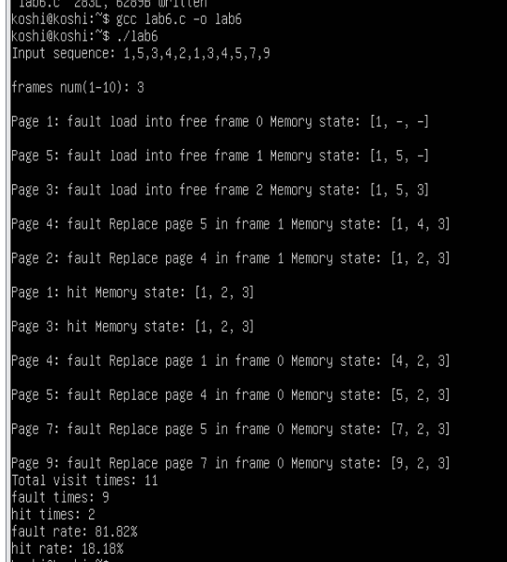
opt运行结果
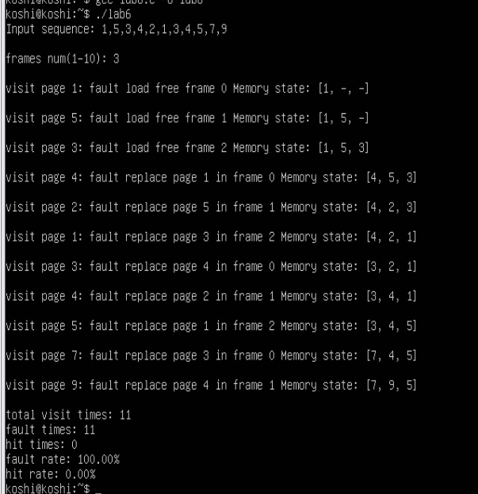
fifo运行结果
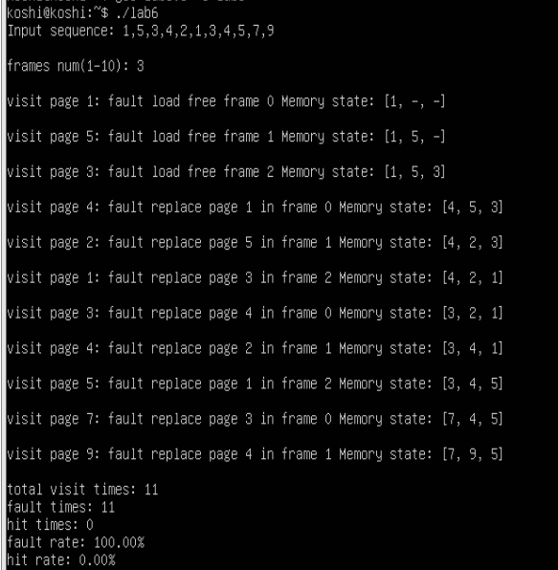
lru运行结果。
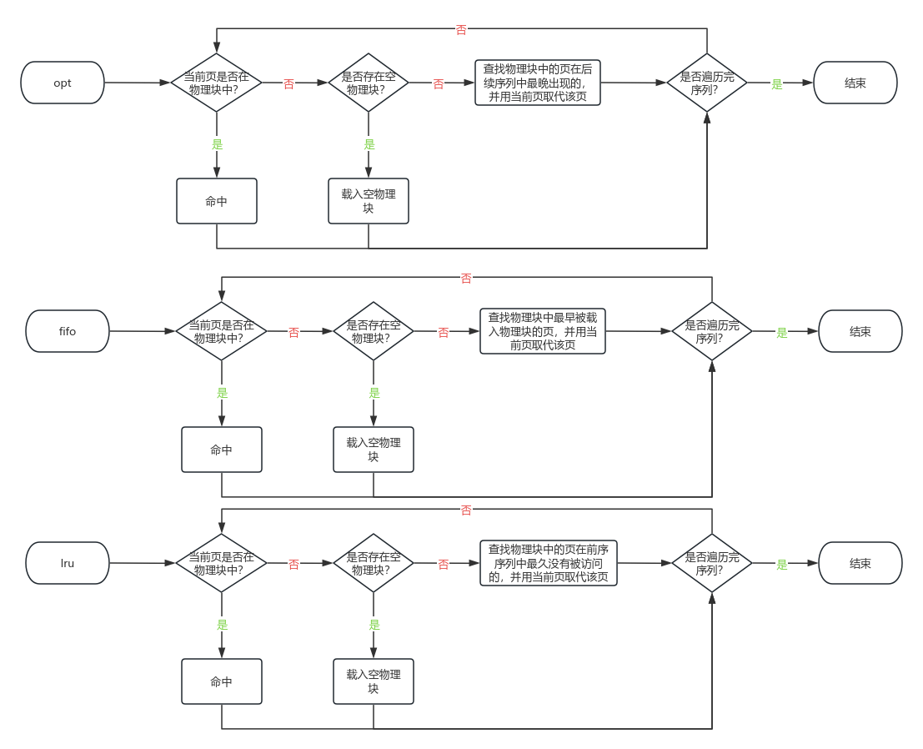

实验总结
本次实验模拟实现了3种页面置换算法，增加了对算法的实现理解。其中opt算法是理想的最佳置换算法，fifo是最易实现的算法，lru是接近opt的算法，尽管运行案例看起来fifo会与lru相同。

